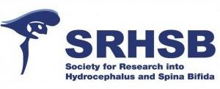
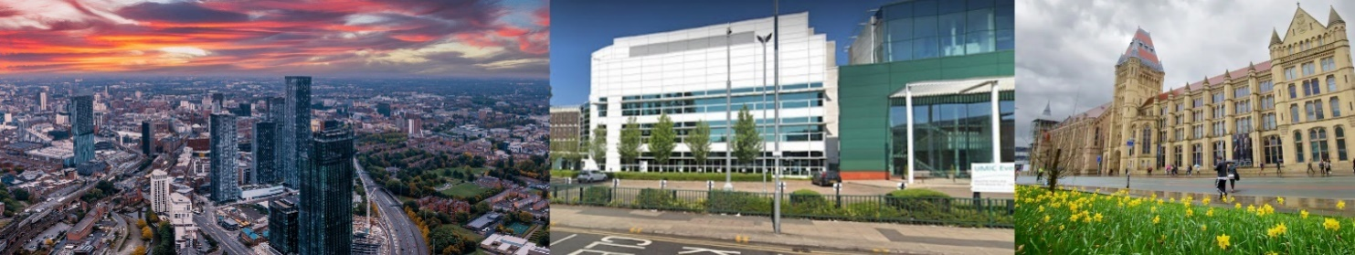
SRHSB 2024 Conference Meeting – University of Manchester
The SRHSB President and Executive Committee invite you to join us at our annual conference to be held on September 4th-6th 2024, in the Dalton Room, at the Core Technology Facility (CTF), University of Manchester
Session topics and keynote speakers
Perspectives on CSF dynamics
Dr Kristopher Kahle (Harvard Medical School, USA)
Professor Satish Krishnamurthy (Upstate Medical University, Syracuse, USA)

Therapeutic approaches to NTDs and hydrocephalus
Mrs Sofia Mastrodima-Polychroniou (University College London, UK)
Mr Will Singleton (University of Bristol, UK)
Mr Conor Mallucci (Alder Hey Children’s Hospital, Liverpool, UK)
Dr Patricia Paez-Gonzalez (University of Málaga, Spain)
Ms Benedetta Pettorini (Alder Hey Children’s Hospital, Liverpool, UK)

Experimental models for hydrocephalus and spina bifida
Professor Pat McAllister (Washington University, St Louis, USA)
Professor Richard Finnell (Baylor College of Medicine, Houston, USA)

Glymphatics and CSF pathways
Professor Roxana Carare (University of Southampton, UK)
Dr Hannah Botfield (University of Birmingham, UK)
Dr Jaleel Miyan (University of Manchester, UK)

Patient perspectives
Mr Andy Wynd (formerly CEO of SBH Scotland, UK)
Ms Gill Yaz and colleagues (SHINE Charity, UK)
Research Student Bursary
Waite Hydrocephalus Research
Student Bursary 2024

Early Career Awards
SRHSB/Integra Travelling Fellowship
Norman Guthkelch Award for Early Career Scientist Conference Essay Prize
Casey Holter Essay Prize

Available SRHSB conference prizes and awards - see below!

Conference Presentation Prizes
Best Clinical Presentation
Best Basic Science Presentation
Best Poster
President’s Prize for Best Presentation

Abstracts Submissions
Oral and poster presentations on themes related to hydrocephalus, spina bifida, NTDs and CSF
For award application forms and abstract submission please go to SRHSB.com

