SRHSB Doha 2022 Conference Report
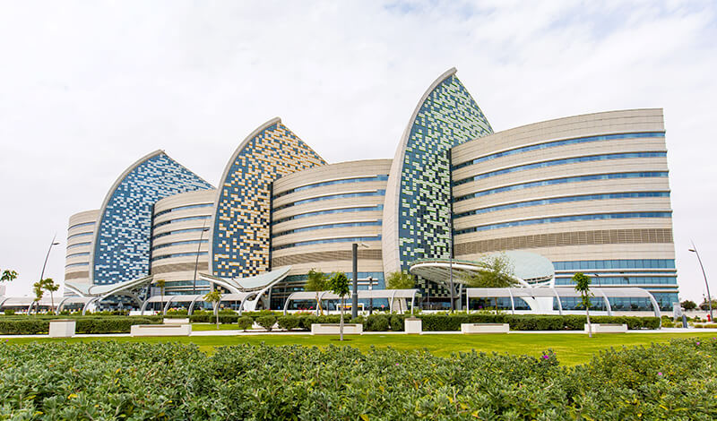
The 66th annual scientific meeting of the Society for Research into Hydrocephalus and Spina Bifida was due to be held face-to-face in Doha, Qatar, but once more circumstances related to the forthcoming FIFA World Cup conspired to force us to convert the meeting from hybrid to purely online, which was a great shame in view of the potential for this to be the first meeting held in the Middle East or Africa. The meeting was combined with the Sidra Pediatric Neuroscience Conference, which is held every 2-3 years and it certainly would have been a great opportunity for researchers and neurologists to mingle and network from all the different specialties and countries if we had been able to hold a face-to-face meeting.
Nevertheless, the meeting went ahead smoothly online over 3 days, managed professionally by Masterbadge and we were treated to an excellent range of scientific presentations and reviews, together with the Casey Holter lecture by Prof. Roger Bayston on surgical implant infections and the historical microbiological principles that Roger has used in his long and outstanding research career.
Scientific papers were given by researchers from the Czech Republic, India, Qatar, Spain, UK and USA and focused on hydrocephalus and spina bifida. Insights, case studies, research and best practice methodologies related to the clinical and surgical management of hydrocephalus and spina bifida were given. The session also featured fascinating patient / parent perspectives from Harry’s Hat Charity founder Caroline Coates and her research colleague Non Hill. Six student researchers who were the beneficiaries of Waite student bursaries (kindly donated by Richard and Jennifer Waite) presented the interesting results of their summer research projects on hydrocephalus, carried out in different research units around the world.
On the last day we had updates from international speakers on the treatment of children’s epilepsy, neurometabolic disorders such as leukodystrophies and neuromuscular disorders including new gene therapies. The afternoon finished with a session on precision medicine in neurological disorders with an outstanding talk by the winner of the President’s Prize, Dr. Sahar Da’as, (details about Dr Da’as and her research are given below) who described the amazing work being carried out in the Zebra Fish Functional Genomics Unit at Sidra Medicine in Doha. Congratulations to Dr. Da’as on her award!
We would like to thank all the presenters for their notable contributions in making this an excellent meeting!

President’s Prize awarded to:
Dr Sahar Da’as PhD, for her presentation:
Functional Precision Medicine Platform for Neurological Disorders
Summary:
The Sidra Medicine Zebrafish Functional Genomics Facility, offers a platform of assays that merges the gap between clinical presentations and genomics findings. This platform represents a fast and reliable screening method for validating candidate novel genes and novel variants in various neurological disorders and rare pediatric hereditary disorders. Zebrafish with a transparent embryonic stage is an ideal vertebrate genetic model organism for the evaluation of brain development, motor neurons, and synaptic function. Recently, we validated the impact of rare biallelic variants in VWA1 identified in 17 individuals from 15 families with autosomal-recessive, non-length dependent, hereditary motor neuropathy. Successfully, phenotypes described in vwa1 zebrafish knockdown and knockout models phenocopied key clinical features described in patients with VWA1 mutations, providing the first direct evidence for a new link between the extracellular matrix VWA1 pathogenic variants’ involvement in neuromuscular disorders.
Biographical profile:
Dr Da’as leads the Sidra Medicine Zebrafish Functional Genomics Facility, offering a platform of assays that merges the gap between clinical presentations and genomics findings. This platform represents an innovative screening method for validating associated genes in diseases predominant in Qatar and rare pediatric hereditary disorders.
Dr Da’as started her research career modelling human diseases at the IWK Health Centre, Canada, working on rare genetic disorders and childhood cancers. Her research interest is validating and characterizing novel genetic variants and novel genes potentially involved in pediatric developmental disorders and neurodegenerative diseases. Her work highlights the zebrafish as a valuable experimental model and offers a roadmap for precision medicine.
Sahar Da’as, PhD
Manager, Research Branch
Zebrafish Functional Genomics Core Facility
t. +974 40037631
m. +974 33309475
PO BOX 26999 Doha, Qatar
sidra.org

